|  |
| --- |
|  |
| **Imagen 1** |
|  |
| **Imagen 2.** |

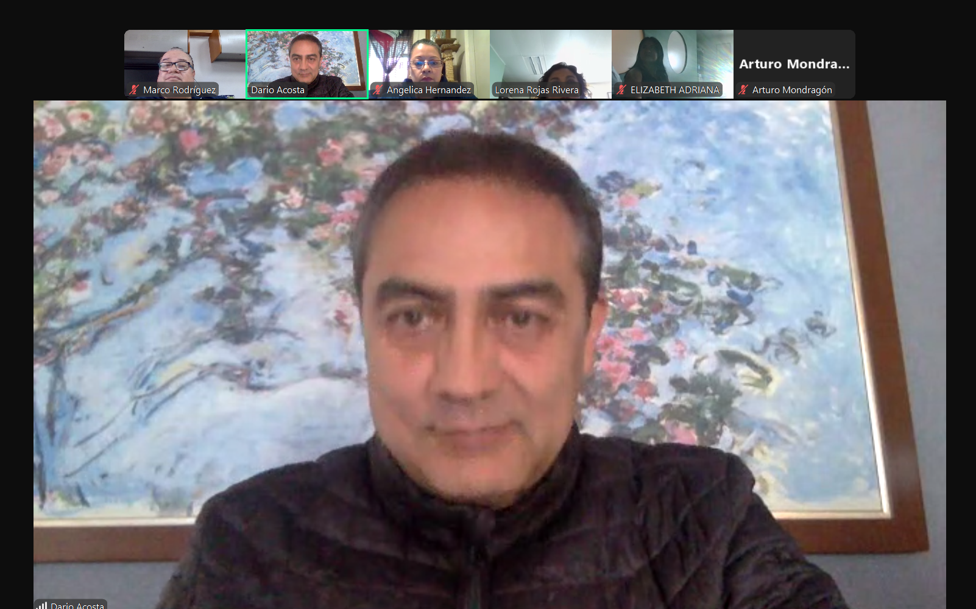

|  |
| --- |
|  |
| **Imagen 3.** |
|  |
| **Imagen 4.** |

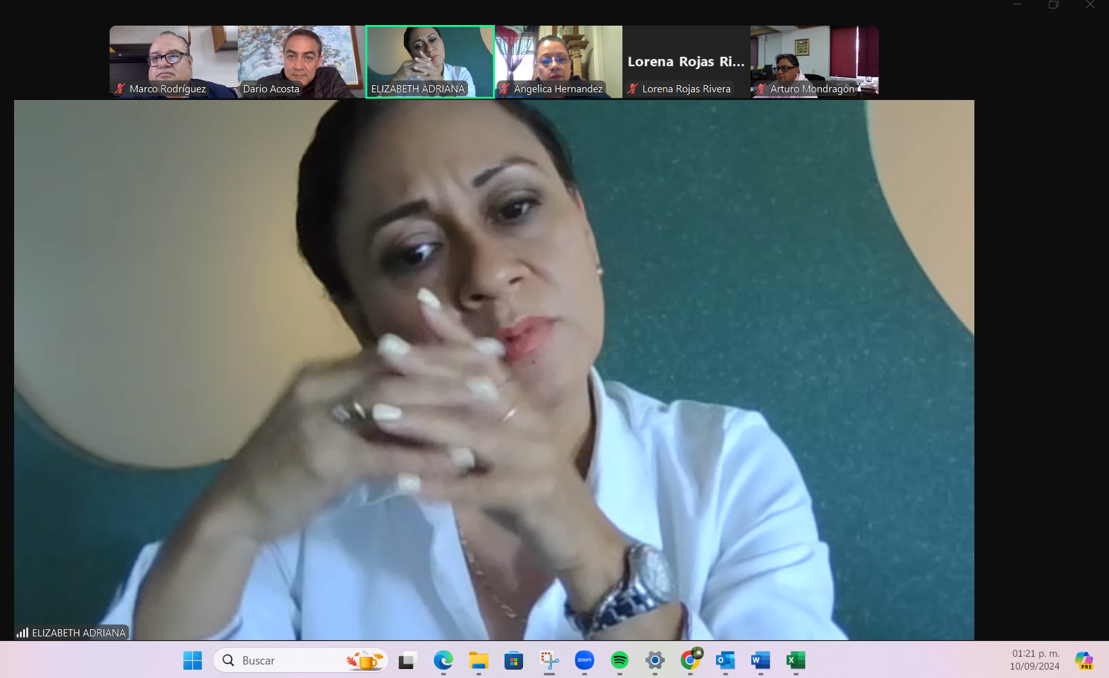

|  |
| --- |
|  |
|  |
|  |
| **Imagen 6.** |